**Assignment No-1 [1]**

**Question:** Draw your Home Network Topology and explain how you are accessing the RPS Lab environment.

**Solution:**

**Diagram:**

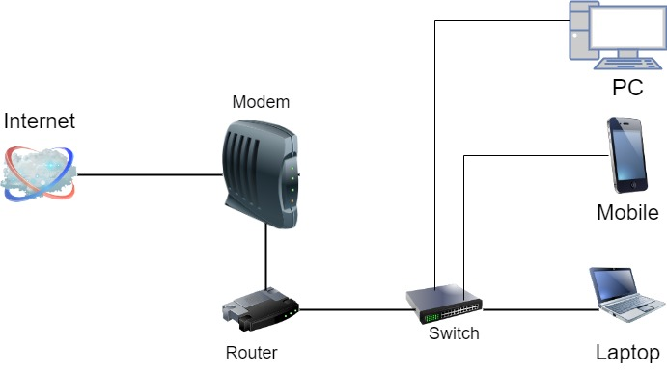

**Explanation:**

**Internet Connection:** The home network connects to the internet via an Internet Service Provider (ISP) through a modem.

**Modem:** The modem translates the ISP's signal into a digital signal that the router can use.

**Router:** The router acts as the central hub of the home network, connecting all devices to the internet and allowing them to communicate with each other. It typically provides wired and wireless connections.

**Devices:** Various devices such as laptops, desktops, smartphones, and smart TVs are connected to the router via wired (Ethernet) or wireless (Wi-Fi) connections.

**Accessing the RPS Lab Environment:**

**Connect to the Internet:** Ensure that my home network is connected to the internet.

**Establish a VPN Connection**: If required by the RPS Lab environment, I would establish a Virtual Private Network (VPN) connection. This would provide a secure connection to the lab's network, allowing me to access resources as if I were physically connected to it.

**Access Lab Resources:** Once connected to the lab's network via VPN, I can access the resources provided by the RPS Lab environment. This may include remote servers, development environments, databases, or other software tools needed for programming and software development tasks.

**Work Remotely:** With access to the lab environment, I can perform programming tasks, run experiments, or collaborate with colleagues remotely, leveraging the resources and capabilities provided by the lab infrastructure.